 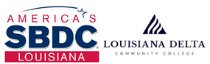

Southern University at Shreveport, LA

3050 MLK, Jr. Dr.

Shreveport, LA 71107

MARCH 30, 2021

**STATE SBA partners with SUSLA to open regional Small Business Development Center to support entrepreneurs and small businesses**

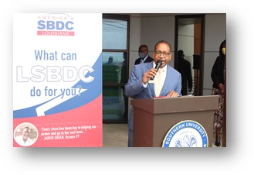

The LSBDC and Southern University at Shreveport (SUSLA) have collaborated to open the Small Business Development Center to serve small businesses and entrepreneurs throughout the Northwest Louisiana Region. The Center is located at 4646 Hilry Huckaby III Avenue, Shreveport, LA 71107 (across from SUSLA’s main campus on MLK).

At no cost to the client, the Center will offer high-quality technical assistance to existing and start-up small businesses, and provide a stronger presence in the Region. Southern University at Shreveport’s Chancellor Dr. Rodney Ellis states, “the Center will serve as a hub of restoration for businesses that have struggled to stay afloat during the pandemic. There has been an increase in businesses reaching out for assistance, with about 60% representing the restaurant and retail industries. The Center will certainly be a welcomed resource for increasing benefits to them as well as others.”

LSBDC Associate State Director Brian Greenwood reiterated sentiments of State Director Carla Holland that, “The Center will increase support for Northwest Louisiana small businesses and entrepreneurs, and… (we) look forward to it becoming the spark of a great economic development push…”. The LSBDC services include no-cost business consulting and affordable training seminars designed to help businesses attract customers, improve operations, increase sales, and successfully access capital.

The opening and ribbon cutting was well attended by community leaders, small business owners, elected officials and local and state agencies. Speakers on the Program included: Dr. Rodney Ellis, SUSLA Chancellor; Hon. Adrian Perkins, Shreveport Mayor; Bryan Greenwood, LSBDC Assoc. State Director; Janice Sneed, Assoc. VC Academic Affairs & Workforce, SUSLA; Darrin Dixon, Dir. Small Bus. Dev., SUSLA and LSBDC Reg. Dir.; Dr. Timothy Magner, Pres. Greater Shreveport Chamber; Billy Anderson, Pres. Shreveport-Bossier African American Chamber.

For more information, please contact SBDC Regional Director, Darrin Dixon at [ddixon@susla.edu](mailto:ddixon@susla.edu) , phone 318-670-9701, or visit the website at [www.LouisianaSBDC.org](http://www.LouisianaSBDC.org)

# # #

Office of Marketing and University Relations

[marketing@susla.edu](mailto:marketing@susla.edu)

(318) 670-6000

*Southern University at Shreveport does not discriminate on the basis of race, color, national origin, gender, age, disability or any other protected class.*

*Title IX Coordinator: Dr. Tuesday W. Mahoney, Johnny L. Vance, Jr. Student Activity Center, Room 208, (318) 670-9201. Section 504 Coordinator: Jerushka Ellis, Health & Physical Education Complex, Room 314, (318) 670-9367*

Visit SUSLA on the web at: <http://www.susla.edu>