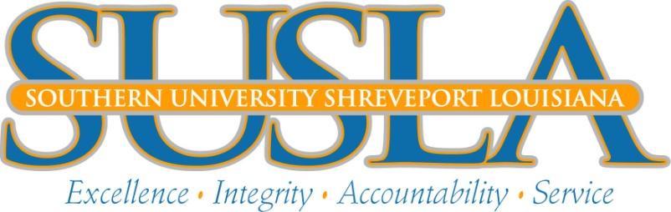

**Office of Marketing & University RElations**

**FOR IMMEDIATE RELEASE**

**September 20, 2016**

Contact:

Bill Strother

Director of Marketing & University Relations

318.670.9472 office

<http://www.susla.edu/press-releases>

[wstrother@susla.edu](mailto:wstrother@susla.edu)

**Southern University at Shreveport receives over $500,000 in training funds**

Southern University at Shreveport has been selected for the third year as the training provider for a renewed partnership with ExpressJet Airlines. Approximately 312 existing ExpressJet employees will benefit from a $592,250 training initiative over the next year. ExpressJet was awarded the money in training funds under SUSLA’s Incumbent Worker Training Program (IWTP) to assist in developing the existing skills of their employees for the purpose of increasing employee productivity and company growth.

The partnership was solidified by collective efforts from SUSLA’s Director of Workforce Development, Beverly Parker, along with the management team at ExpressJet Airlines. ExpressJet employs 8,500 aviation professionals and operates an average of 1,500 daily flights for American Eagle, Delta Connection and United Express. SUSLA Chancellor, Dr. Rodney Ellis said, “This underscores SUSLA’s renewed commitment to providing the regional community with the skilled workforce needed to expand economic opportunities for its citizenry. We want to insure all local employers that we are committed to partnering with them to strengthen the workforce in Northwest Louisiana. On behalf of the ExpressJet management team, they stated, “We are exceedingly appreciative of the Louisiana Workforce Commission for granting funds to support the training needs of our incumbent employees.  The funds will allow us to address and enhance current training initiatives, as well as the provision for ongoing recurrent training needed in the workplace at our Shreveport and Baton Rouge maintenance bases.  We are also pleased to have SUSLA, once again, as our Training Provider to manage our grant and to provide the support needed in accomplishing our long-range training plans.” 

Airline maintenance forecasting shows the global airline industry will need approximately 34,000 new airplanes (double the current number) in the United States by 2031 and commercial airlines will require 601,000 new aircraft maintenance technicians in the next 20 years to maintain that fleet. With many jobs on the horizon for Aviation Maintenance, SUSLA is committed to not only training existing Aircraft Maintenance professionals, but, putting more mechanics in the workforce through our high demand Airframe and Powerplant Maintenance program. SUSLA is the only community college in north Louisiana to produce technicians with required certificates and FAA certifications for the Aerospace/Aviation industry. Graduates from the SUSLA program average $40K starting pay and have the potential to earn $70K within five to seven years.

**The Incumbent Worker Training Program was created in 1997 by the Louisiana Legislature Workforce Commission to assist business and industry in developing/upgrading the skills of their employees. The IWTP is a partnership comprised of the LWC, employers and training providers. For more information about how your company can access funds for employee training, contact Ms. Beverly Parker (bparker@susla.edu). For more information on the** Airframe and Powerplant Maintenance academic program, contact Mr. Timothy Banks, Interim Director of the Airframe and Powerplant Maintenance program ([tbanks@susla.edu](mailto:tbanks@susla.edu)).

***Southern University at Shreveport, an institution within the Southern University System, seeks to provide a quality education for its students, while being committed to the total community. This institution prepares students for careers in technical and occupational fields; awards certificates and associate degrees as well as offerings and programs that are transferable to other colleges and universities. Dedicated to excellence in instruction and community service, this open enrollment institution promotes cultural diversity, provides developmental and continuing education, and seeks partnerships with business and industry.***

Visit SUSLA on the web at: http://www.susla.edu